M. Tech in Computer Science and Engineering

Practice exercise in SQL

1. Specify the following queries in SQL on the COMPANY relational database schema shown in Figure below. Show the result of each query if it is applied to the COMPANY database in Figure below.

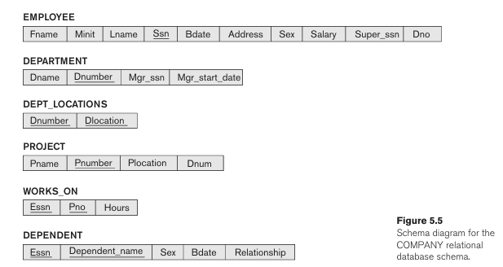

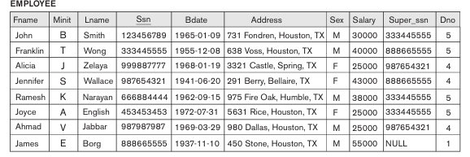

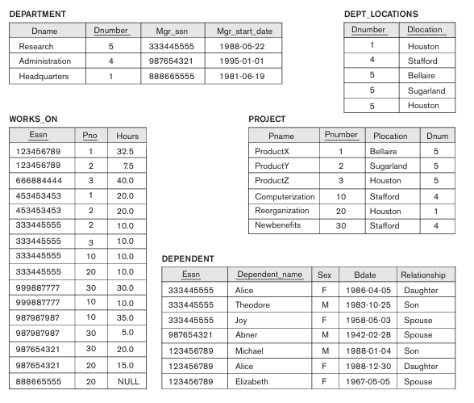

1. Retrieve the names of all employees who belong the “Research” department.
2. Retrieve the names of all employees in department 5 who work more than 10 hours per week on the ProductX project.
3. Find the names of all employees who are directly supervised by ‘Franklin Wong’.
4. Retrieve the names of employees who earn more than the average salary in their department.
5. Retrieve the department names along with the total number of employees in each department.
6. Consider the Employee database given below. The primary keys are underlined. Assume relevant data types for attributes.
7. Retrieve the name of all employees whose salary is greater than the

salary of all employees in dept 5.

1. Retrieve the ssn of all employees who work on project numbers 1,2 or 3
2. Display the total Number of hours put in by all employees on every

project.